ILDN Social Enterprise IMPACT Awards

Frequently Asked Questions

All questions relating to the ILDN Social Enterprise Impact Awards should be submitted by email to SEImpactAwards@ildn.ie. The deadline for submission of questions is 11.59pm on 3rd December 2023.
This Document was last updated on: 27th October, 2023

- Are social enterprises that pursue a purely environmental mission eligible to apply?
Social enterprises that pursue environmental objectives are welcome to apply; however, to ensure consistency with the aims and scope of the Dorman Accounts Fund – which focuses on addressing economic, social and educational disadvantage, or supporting those with a disability – such organisations are encouraged to clearly specify the benefits to people (and not just the environment) arising from the work that they do.

- Are there restrictions on how they prizemoney can be spent?
Prizemoney can be used to cover any expenses incurred by the social enterprises. This can include both capital expenses (e.g., building and renovation works, equipment, etc.) and current expenses (e.g., utility bills, insurance). However, awardees are required to indicate to ILDN on or before 30th April 2024 how prizemoney will be used.

- If unsuccessful, will it be possible to get feedback on where they lost marks to help in future funding applications?
While we will endeavour to provide some qualitative feedback on all applications, our ability to do so will depend on the volume of applications that we receive.

- Would a Social Enterprise which is a CSP be eligible to apply for these awards?
Organisations in receipt of Community Services Programme funding are eligible to apply assuming they meet the eligibility criteria set out in the Call for Submissions.
- Will early years services be eligible to apply?
Providers of early years services may apply, assuming they meet all eligibility conditions set out in the call for submissions (including the requirement to be bound by an asset lock, meaning that the organisation’s assets will transfer to another organisation with a similar mission in the case of dissolution).

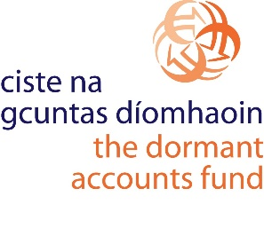

The ILDN Social Enterprise Impact Awards
are supported by

