ILDN Social Enterprise IMPACT Awards

Application Form

- For further information relating to this call, please visit: ildn.ie/themes/socialenterprise
- If you have any questions, please send them by email to SEImpactAwards@ildn.ie. Questions will be answered via a Frequently Asked Questions document that is available at: ildn.ie/themes/socialenterprise
- All applicants are advised to check this document for information and updates regularly.
- Please ensure that you complete all sections of this Application Form (Sections 1 & 2, including subsections).
- Graphics, webpages, or other supplementary materials may be submitted as appendices; please ensure that you refer clearly to any such materials within the relevant section(s) of the application form.
- Please send completed application forms by email to SEImpactAwards@ildn.ie

Key Dates
3rd December 2023 (11.59pm) | Deadline for submission of questions. Only technical questions will be answered after this date.
10th December 2023 (11.59pm) | Application deadline
12th January 2024 | Applicants notified of competition outcome
20th February 2024 | Prizegiving ceremony in Dublin

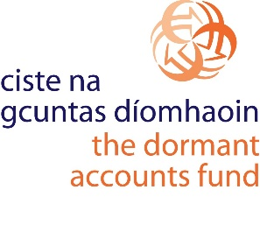

The ILDN Social Enterprise Impact Awards
are supported by

SECTION 1

Organisation Name: _________________________________
Company Number: _________________________________
Tax Reference Number: _________________________________
Charity Number: _________________________________
(Optional – applicant organisations are not required to be a registered charity.)
Date Established: _________________________________
Number of Employees –
Full-time: _____
Part-time: _____
Seasonal: _____
Address: _________________________________
_________________________________
_________________________________
Website: _________________________________
Contact Person Name: _________________________________
Role: _________________________________
Email address: _________________________________
Phone Number: _________________________________

By signing below, I confirm that, to the best of my knowledge, all information provided within this application is correct and up to date.
Signed: _________________________________
Date: _________________________________

SECTION 2
To allow for anonymous scoring, please do not name your organisation, or any individuals affiliated with it, within this section. Place names may be included.

Outline the main activities of your organisation, including its social/environmental mission and its income model.
250 words or less

Describe the strategies employed by your organisation to monitor and measure its social/environmental impact. In other words, describe your approach to proving that your organisation generates social/environmental value. You may wish to refer here to one or more of the following:
- Theory of Change or other impact framework;
- outputs/outcomes;
- the use of primary and/or secondary data;
- key performance indicators;
- stakeholder consultations;
- observational techniques.
750 words or less

Provide an overview of the social/environment impact(s) that your organisation has achieved over the past 12-24 months. In other words, explain the key insights that have emerged from your impact-monitoring or impact-measurement activities.
750 words or less

