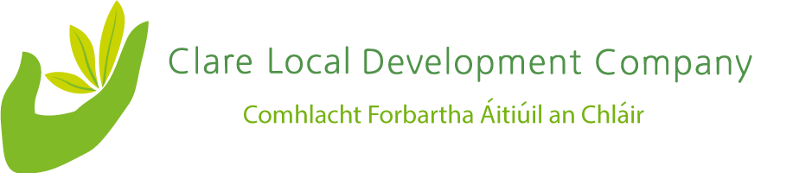
All those making a submission are asked to use the following format.
Name
Organisation
Role
Email/ contact details

- Please provide a brief description of your organisation and your target groups/ communities.

- What - if any - is your organisation's current involvement with social enterprises?

- What areas of activity do you believe offer potential for social enterprise development? For example, tourism, recreation, social services, green economy, training and education, retail, etc.

- What do you believe are the challenges faced by social enterprises?

- Does your organisation provide support to social enterprises? If yes, please can you elaborate?

- What recommendations do you have for the development of a strategy to support social enterprise development in Co Clare?

Deadline
Please send your submissions via email to Tanya Lalor, Method Consultants tanya@methodconsultants.ie by Thursday 12th May 2022.
Please note that all submissions will be treated in confidence.

